**Module Pool Programming with Tab Strip Control**

***Program theme:*** *In this demo program you will get how to work Module Pool with the Tab Strip Controls and the result displayed in the table format.*

**Step # 1:** Go to SE38 / SE80 Transaction code and create a Module Pool Program (Program Type – M).

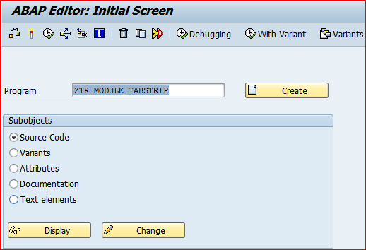

**Step # 2:** Provide the title and select program type Module Pool - M and click on save button.

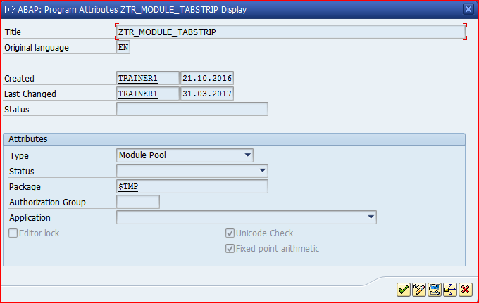

**Step # 3:** Save it in the package.

**Step # 4:** Write module pool program code logic based on the events.

*\*&---------------------------------------------------------------------\**  
*\*& Modulpool  ZTR_MODULE_TABSTRIP*  
*\*&---------------------------------------------------------------------\**  
PROGRAM ZTR_MODULE_TABSTRIP.  
  
TABLES : MARA.  
  
DATA T_LINKS TYPE TABLE OF TLINE.  
  
CONTROLS TC1 TYPE TABLEVIEW USING SCREEN 120.  
  
CONTROLS TABSTRIP TYPE TABSTRIP.  
  
TYPES : BEGIN OF TY_TAB,  *" LOCAL STRS*  
          MATNR TYPE MATNR , *" Material Number*  
          MBRSH TYPE MBRSH, *" Industry sector*  
          MTART TYPE MTART, *" Material Group*  
          MEINS TYPE MEINS, *" Base Unit of Measure*  
          BRGEW TYPE BRGEW, *" Gross Weight*  
          NTGEW TYPE NTGEW, *" NET Weight*  
        END OF TY_TAB.  
  
DATA :IT_TAB TYPE STANDARD TABLE OF TY_TAB, *"  ITAB*  
      WA_TAB TYPE TY_TAB.  *" WORKAREA*  
  
DATA: LV_MATNR1 TYPE MARA-MATNR,  
      LV_MATNR2 TYPE MARA-MATNR.  
*\*&---------------------------------------------------------------------\**  
*\*&      Module  STATUS_0100  OUTPUT*  
*\*&---------------------------------------------------------------------\**  
  
MODULE STATUS_0100 OUTPUT.  
  
  SET PF-STATUS 'ZTRPFS9'.  
  
ENDMODULE.  
  
*\*&---------------------------------------------------------------------\**  
*\*&      Module  USER_COMMAND_0100  INPUT*  
*\*&---------------------------------------------------------------------\**  
  
MODULE USER_COMMAND_0100 INPUT.  
  CASE SY-UCOMM.  
    WHEN 'TAB1'.  
  
      TABSTRIP-ACTIVETAB = 'TAB1'.  
  
    WHEN 'TAB2'.  
  
      TABSTRIP-ACTIVETAB = 'TAB2'.  
  
    WHEN 'EXIT'.  
  
      LEAVE PROGRAM.  
  
  ENDCASE.  
ENDMODULE.  
*\*&---------------------------------------------------------------------\**  
*\*&      Module  USER_COMMAND_0120  INPUT*  
*\*&---------------------------------------------------------------------\**  
MODULE USER_COMMAND_0120 INPUT.  
  
  SELECT MATNR  
         MBRSH  
         MTART  
         MEINS  
         BRGEW  
         NTGEW  
    FROM MARA  
    INTO TABLE IT_TAB  
    WHERE MATNR  
    BETWEEN LV_MATNR1 AND LV_MATNR2.  
ENDMODULE.  
*\*&---------------------------------------------------------------------\**  
*\*&      Module  MAT_MAST  INPUT*  
*\*&---------------------------------------------------------------------\**  
*\*       text*  
*\*----------------------------------------------------------------------\**  
MODULE MAT_MAST INPUT.  
  
  DATA: BEGIN OF IT_TAB2 OCCURS 0,  
  
         MATNR TYPE MATNR,  
  
        END OF IT_TAB2.  
  
  SELECT MATNR FROM MARA INTO TABLE IT_TAB2.  
  
  CALL FUNCTION 'F4IF_INT_TABLE_VALUE_REQUEST'  
    EXPORTING  
      RETFIELD    = 'MATNR'  
      DYNPPROG    = SY-REPID  
      DYNPNR      = SY-DYNNR  
      DYNPROFIELD = 'MATNR'  
      VALUE_ORG   = 'S'  
    TABLES  
      VALUE_TAB   = IT_TAB2.  
  IF SY-SUBRC <> 0.  
*\* Implement suitable error handling here*  
  ENDIF.  
  
ENDMODULE.  
*\*&---------------------------------------------------------------------\**  
*\*&      Module  MAT_HELP  INPUT*  
*\*&---------------------------------------------------------------------\**  
*\*       text*  
*\*----------------------------------------------------------------------\**  
MODULE MAT_HELP INPUT.  
  
  CALL FUNCTION 'HELP_OBJECT_SHOW'  
    EXPORTING  
      DOKCLASS          = 'TX'  
      DOKLANGU          = SY-LANGU  
      DOKNAME           = 'DEMO_FOR_F1_HELP'  
      DOKTITLE          = 'MAT MASTER HELP'  
      CALLED_BY_PROGRAM = SY-REPID  
      CALLED_FOR_TAB    = 'MARA'  
      CALLED_FOR_FIELD  = 'LV_MATNR1'  
    TABLES  
      LINKS             = T_LINKS  
   .  
  IF SY-SUBRC <> 0.  
*\* Implement suitable error handling here*  
  ENDIF.  
  
ENDMODULE.

**Step # 5:** Go to SE51/ SE80 Transaction code and provide the Module Pool Program Name and Screen Number.

Note: Module pool program name and screen program name should be same and for screen number you can enter any number other than 1000 (screen number 1000 is reserved for the selection screen - reporting).

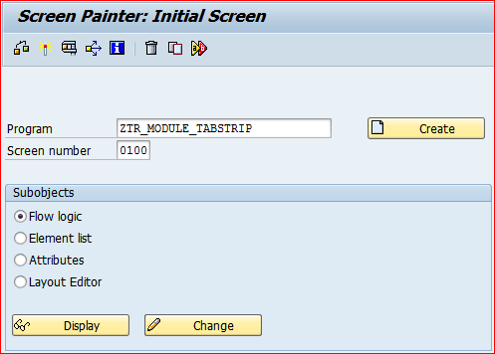

**Step # 6:** Provide the short description and select the screen type radio button Normal.

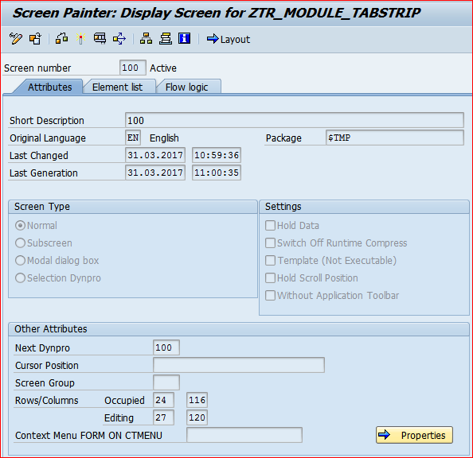

**Step # 7:** Click on Layout button to design the First Screen 100.

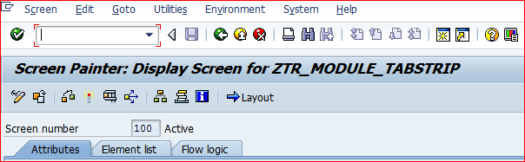

**Step # 8:** Click on the Flow Logic and write the code as showed in the below screen.

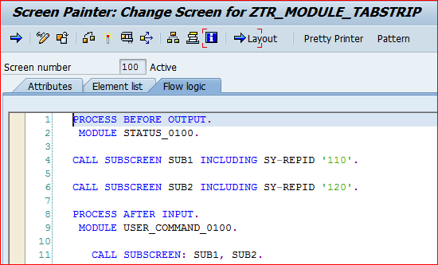

**Step # 9:** Go to Layout, Design the Normal Screen 100 with TAB STRIP and SUBSCREENS

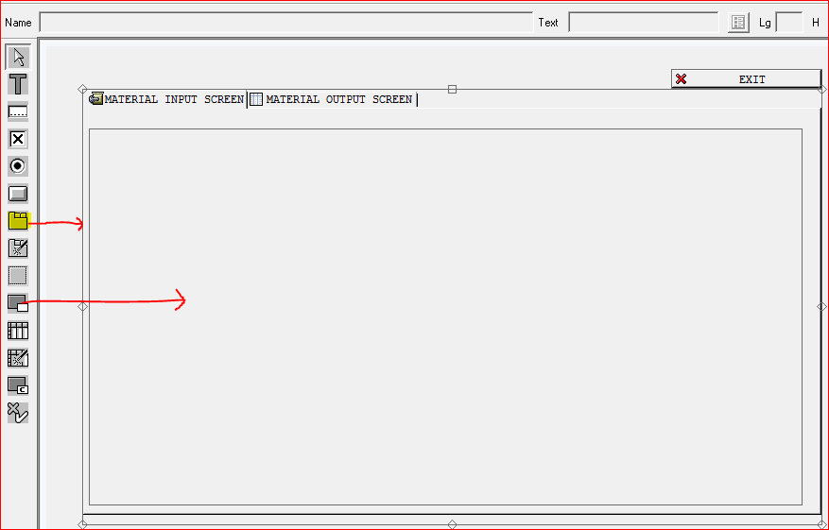

IN REF FIELD , give SUB1 for first tab

Similary , give Sub2 for second tab.

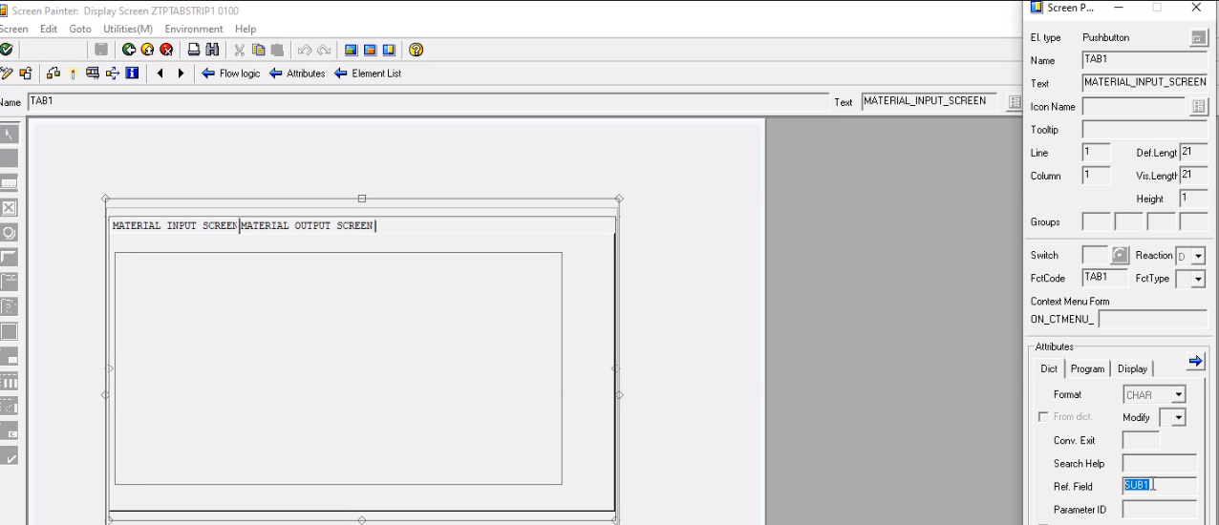

**Step # 10:** Back to initial screen and create the screen 110. Provide the short description and select the screen type radio button subscreen.

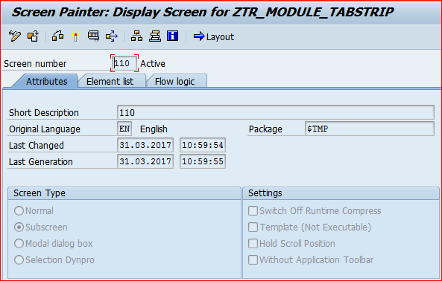

**Step # 11:** Click on the Flow Logic and write the code as showed in the below screen.

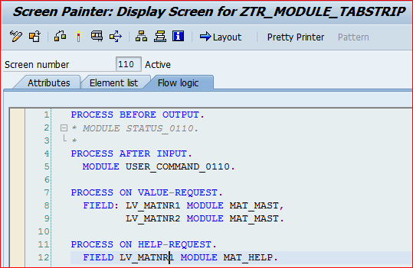

**Step # 12:** Go to Layout, Design the two input fields (LV_MATNR1 and LV_MATNR2).

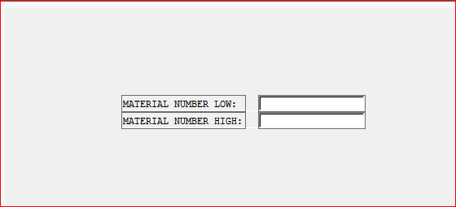

**Step # 13:**  Back to initial screen and create the screen 120. Provide the short description and select the screen type radio button subscreen.

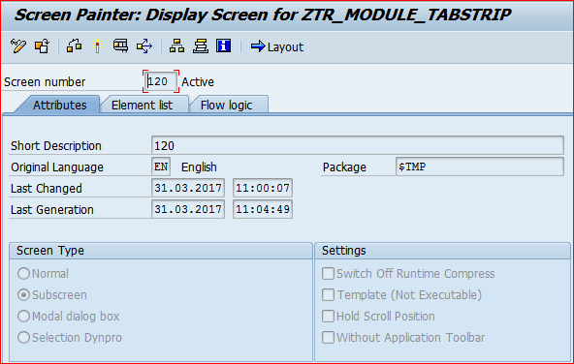

**Step # 14:** Click on the Flow Logic and write the code as showed in the below screen.

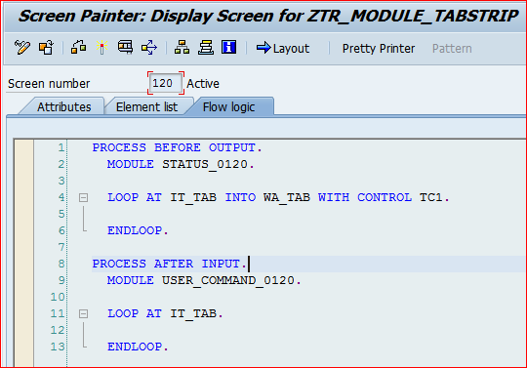

**Step # 15:** Go to Layout, Design with table control for output display.

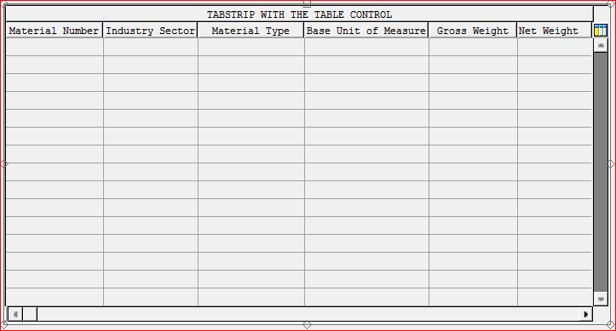

**Step # 16:** Activate the Screen 100, 110 and 120.

**Step # 17:** Activate the SE38 / SE80 Module Pool Program.

**Step # 18:** Go to Transaction Code SE93 / SE80 to create the user defined module pool t-code for the designed application.

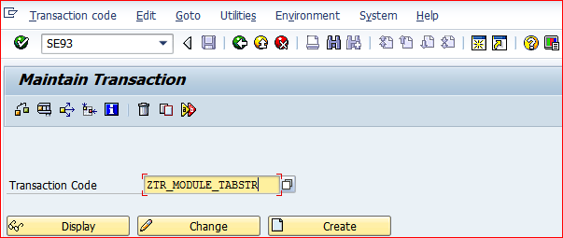

**Step # 19:** Provide the transaction text, program name and initial screen number.

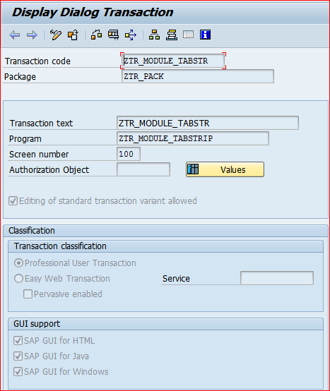

**Step # 20:** Provide the user defined T-Code in the initial screen command and run the Module Pool Application.

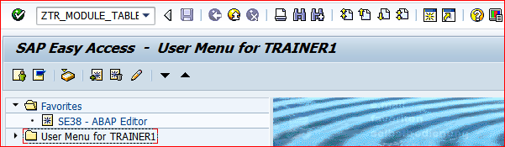

**Step # 21:** 1) Click on Tab **MATERIAL INPUT SCREEN** to provide the Inputs.

Click on the F4 (POV Option) Icon and select the Material Number Low and Material Number – High range and click on Tab **MATERIAL OUTPUT SCREEN** to check the result.

2) Click on EXIT Button to leave the program.

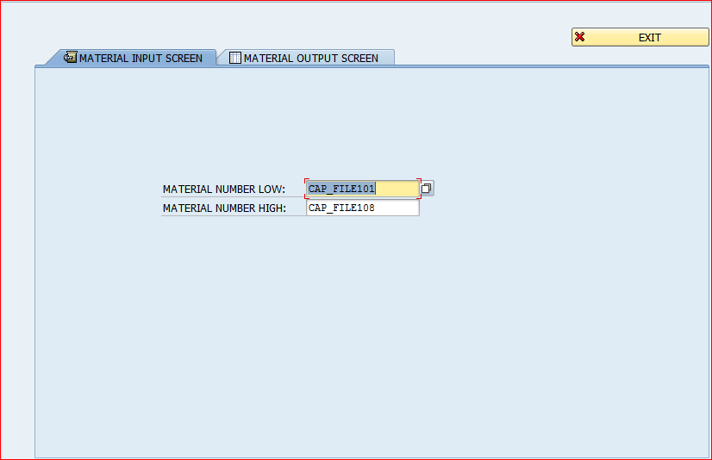

**Step # 22:**  Displayed Tab Strip control Output in the Table Control Format.

1) Click on Tab **MATERIAL INPUT SCREEN** to change the input selection again.

2) Click on EXIT Button to leave the program.

